CSE 233 Lab-4
Mehmet Hüseyin YILDIZ
200104004095

Why Thevenin and Norton Theorems are used in the circuits ?

Thevenin and Norton Theorems used circuits to simplify. If we don’t want to calculate and deal with a complex part of the circuit. We apply Thevenin and Norton theorems.

How Norton current and Thevenin voltage are found in a circuit ?

We find the R equivalent between nodes by making all independent sources off. We calculate or measure the voltage between 2 open nodes. This is thevenin voltage. Then calculate current using voltage or mesaure current between 2 open nodes. This is norton current.

R_{L} for the maximum power transfer is 3.3k ohm.

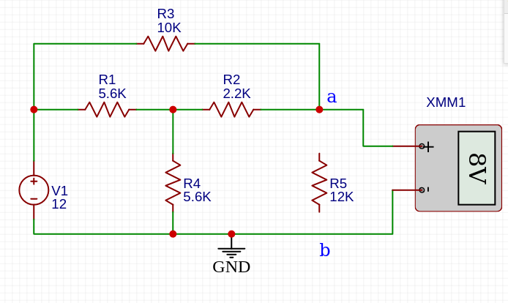
V_{TH}

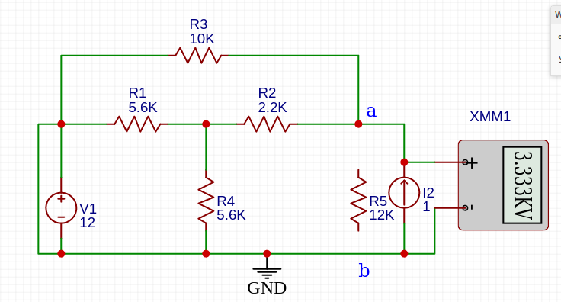
R_{TH} (3.3k ohm)

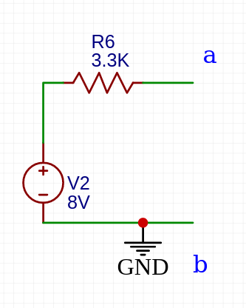
Thevenin Equivalent Circuit

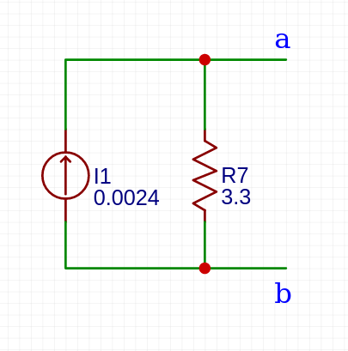
Norton Equivalent Circuit

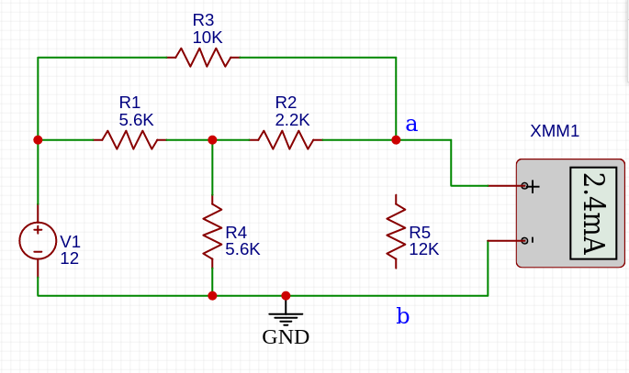
I_{N} Norton short circuit current (equivalent to current in norton circuit)

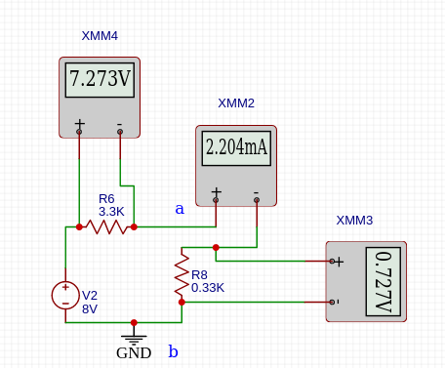
R_{L} = 0.1R_{Th}

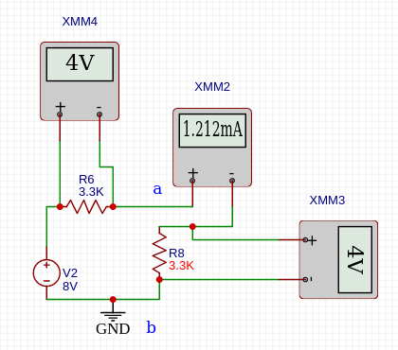
R_{L} = 0.1R_{Th}

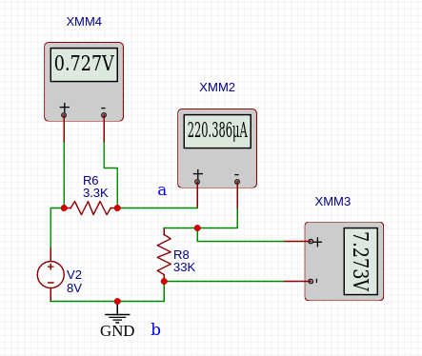
R_{L} = 10R_{Th}

Load Res | Meas  IRL  (mA) | Meas  VRL  (V) | Meas  PRL  (mW) | Meas  PRth  (mW) | Calc  IRL  (mA) | Calc  VRL  (V) | Calc  PRL  (mW) | Calc  PRth  (mW)
R_{L} = 0.1R_{Th} |  |  |  |  | 2.204 | 0.727 | 1.6 | 16
R_{L} = R_{Th} |  |  |  |  | 1.212 | 4 | 4.848 | 4.848
R_{L} = 10R_{Th} |  |  |  |  | 0.220386 | 7.273 | 1.6 | 0.16

